Visualizing the Future at Pleasant Valley
Since acquiring the Pleasant Valley location from the Arborio Family in 2012 – the site has been in a constant state of flux – positive change. Ramps we re-located to improve efficiencies, virtually all of the hauling and loading equipment has been upgraded, the secondary and finish crushing equipment and structures have been replaced – the site has essentially been rebuilt. Now were tackling the landscape itself. After conception of the plan we attended several Planning and Zoning Board meetings, held informational meetings and site visits for our neighbors and the Towns Board Members, and applied for a NYSDEC for a permit modification for the berm construction prior to receiving project approval. Although the Town neighbors and Board members were very thorough in their review of the project they quickly saw the benefits of the project.
Here’s the view from North Avenue “before” construction began a few weeks ago. Although the stockpiles have been there for as long as most people remember – we agreed that we could create a better viewshed for our neighbors as well as a safer travel way for construction vehicles entering and exiting the site and perhaps better shelter North Avenue and our neighbors from some noise and dust.
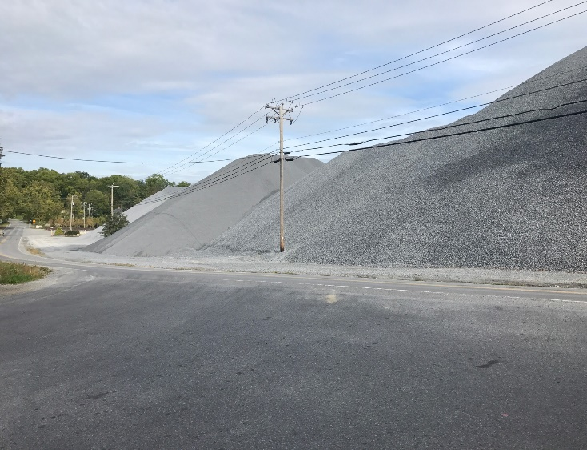
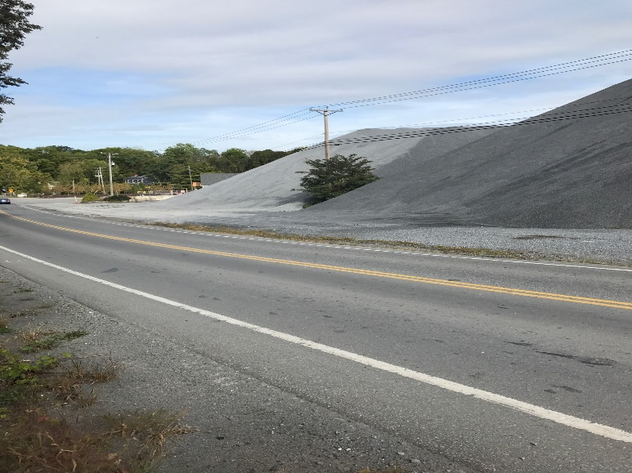
The plan consists of moving all the stockpiled material to other parts of the site, stripping/moving the soil then drilling/blasting the entire area under the finish material conveyors. The area cleared adjacent to North Avenue will have a natural looking vegetated berm planted with various native species of plantings.
Currently, construction has completed moving the stockpiled material, stripping the area and we’ve begun drilling and blasting the 60,000 tons of material to be removed from the area.
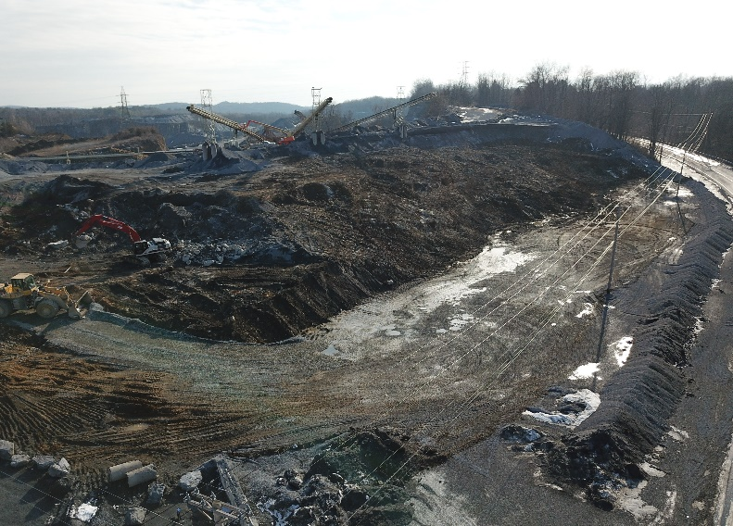
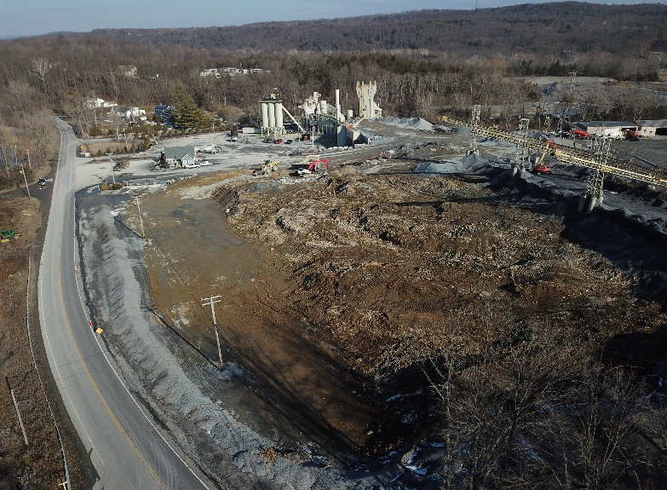

Following the completion of material removal will be the installation of the berm and native species plantings. We are confident that this project will make the site safer and more efficient for construction traffic and the traveling public, shield our neighbors from noise and dust, create a visually appealing landscape for the public and help to continue the strong community relationships that the Arborio Family started in Pleasant Valley in 1937.
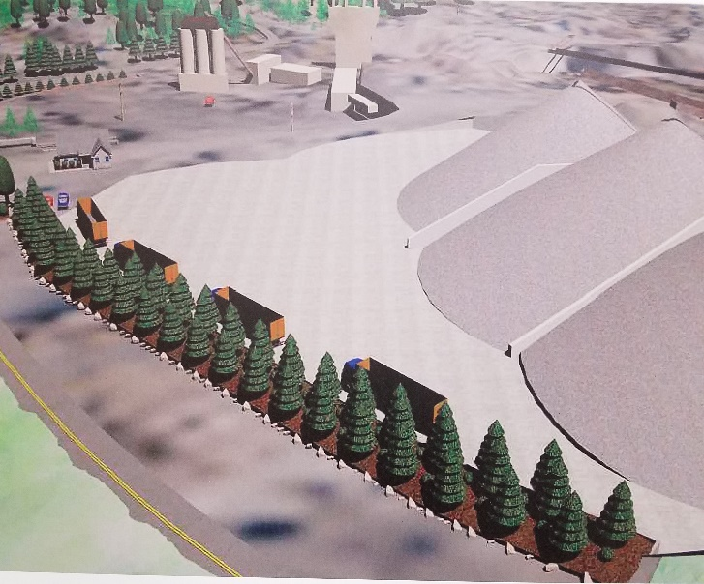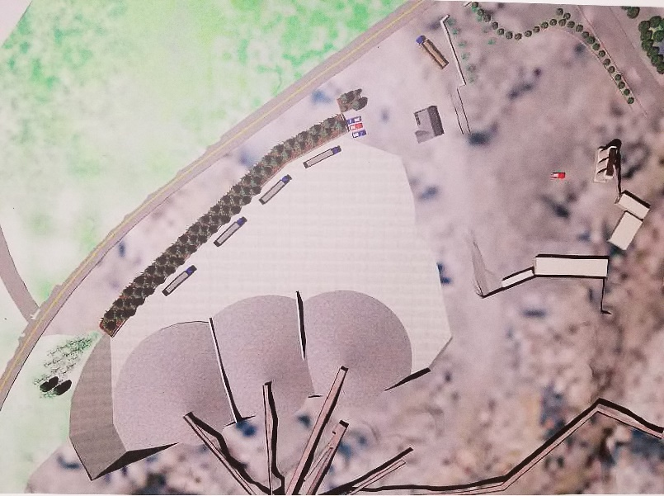

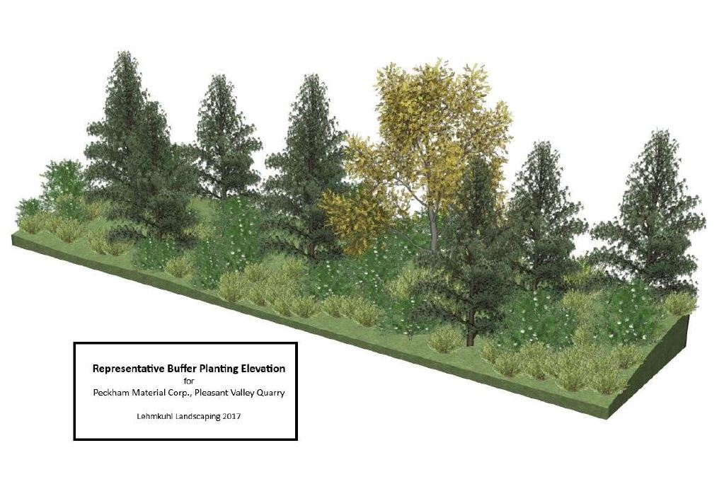
Chris Suttmeier, Pleasant Valley
New Scale House Takes the Weight Off of Plant Clerks and Customers
Pleasant Valley added a new state of the art scale house to not only enhance the looks of the facility, but to update the way we operate. The new layout allows the clerks to better see the scale, and customers to better enhance safety and accuracy when loading in and out in our facility. We strive to update and modernize our facilities with both layout, and technology so we can be safer, smarter and more efficient with all activity throughout all of our locations, not just for our employees and customers, but our neighbors as well.
Kevin McCarthy

